FIRM MANAGEMENT CORPORATION

Suite 200 – 1931 Mt. Newton X Road Phone: 250-544-2300
Saanichton, BC V8M 2A9
Dear Owner,
Firm Management Corporation is proud to announce its new webpage. This new interactive page will allow you the owner, to view your Strata Corporation related documents including council minutes, AGM minutes, memos and financial information.

GETTING STARTED
Simply go to www.firmmanagement.com/portal to reach our home page.

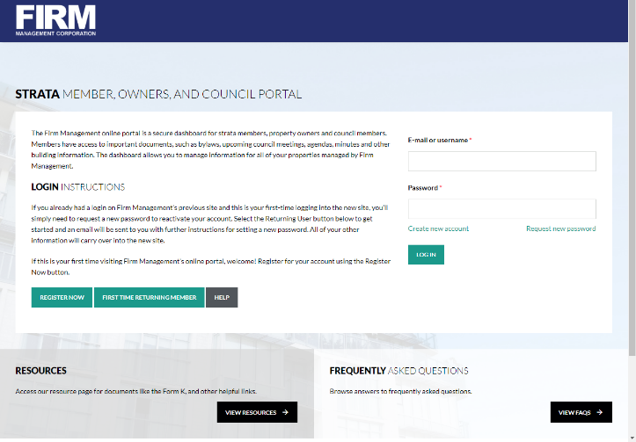
- Click on “Register Now”
- Enter your information
- Click “Create New Account”

Once approved, an automatic email will be sent with instructions on how to login and change your password.

If you need assistance setting up your user account please contact our web page liaison Jennette Miao, jennette@firmmanagement.com.

WHAT CAN I DO?
With the new Firm Management Webpage, you are able to view many documents at your leisure as well as receive notifications from the Property Manager for building memos and notices.

Documents Available.
- Bylaws
- Depreciation Reports
- Financial Reports
- Rules
- Building Notices
- Meeting Notices and Agendas
- Meeting Minutes

IS IT SECURE?
Firm Management strives to protect the information collected by Strata Corporations. All information is on a secured server with multiple backups.

